Here is how I design the product sticker, our company will use 15 ml transparent glass bottles as packaging. A bottle of perfume is sold for RM99. We will put the price sticker on the perfume box, not on the perfume bottle.
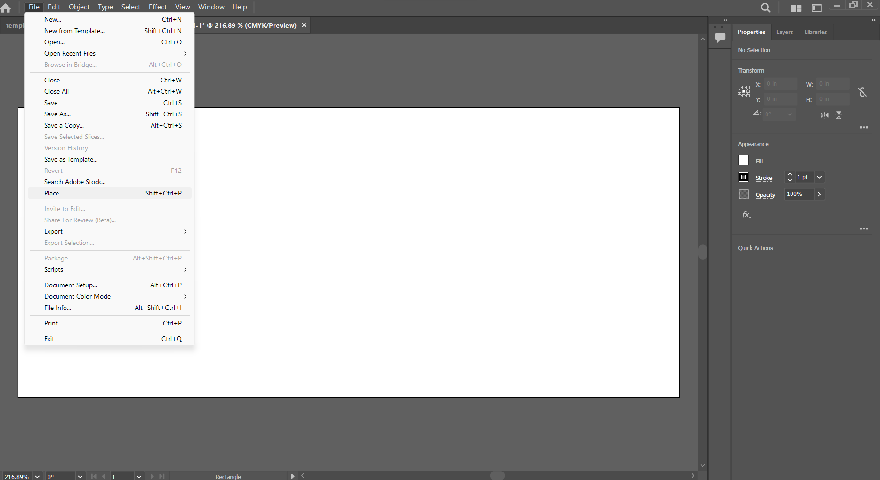
1.

I am using adobe illustrator to design our company product sticker, for the layout format I am using size 8 inches of width and 3.5 inches of height.

2. 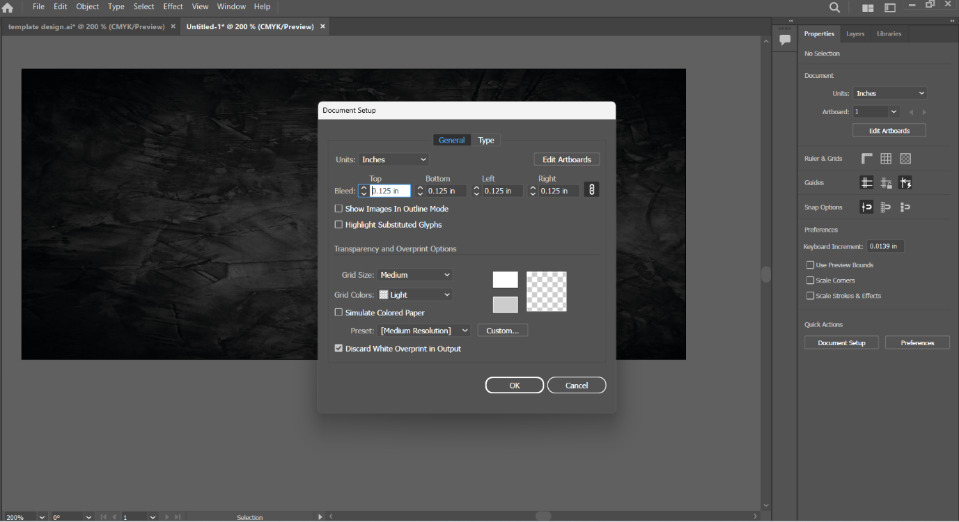
Then I add the background picture inside and set the bleed area to 0.125 inches.

3.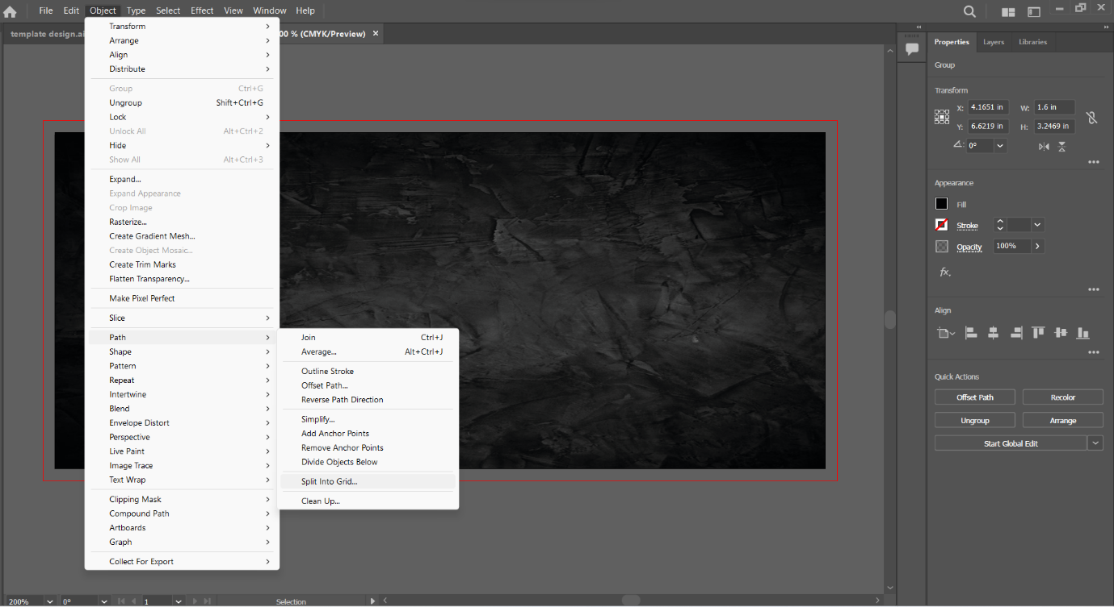
After the bleed area done, then I use the rectangle tool to drag out a black colour background, and make it become 3 path of column in the layout pages.

4.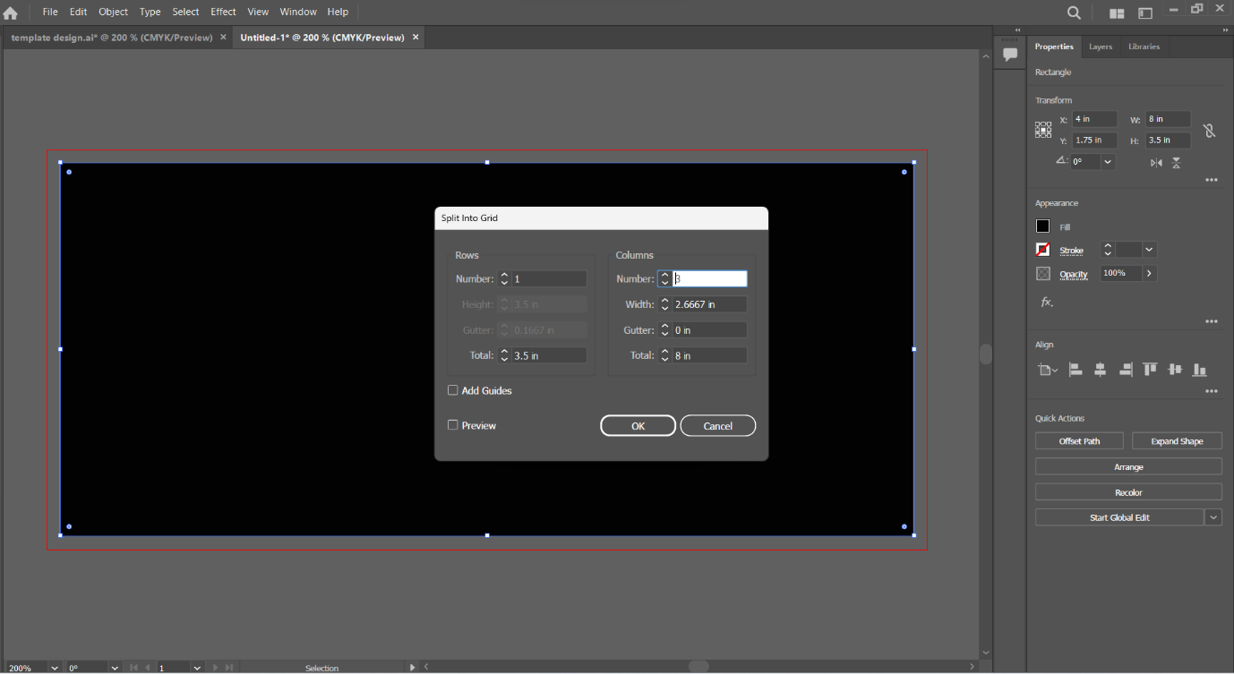

5.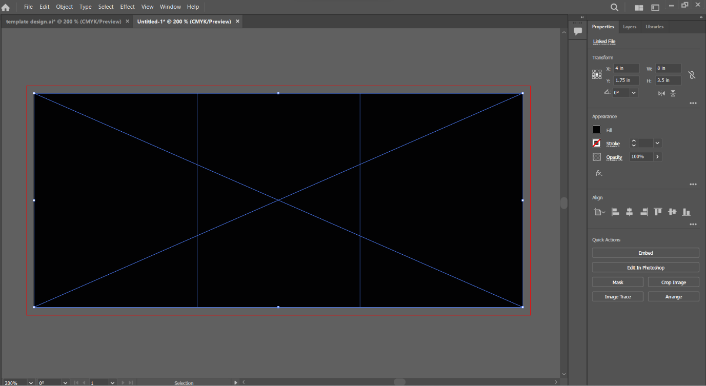

6.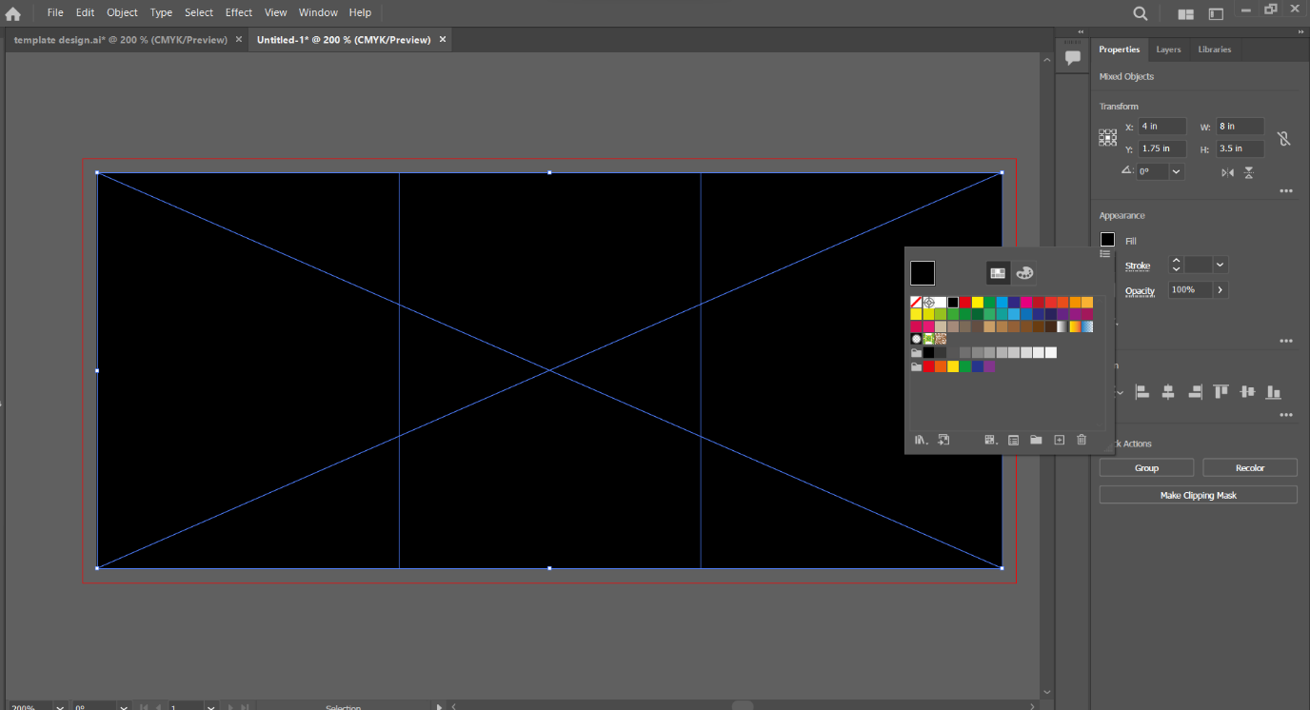
I set the background colour as none.

7.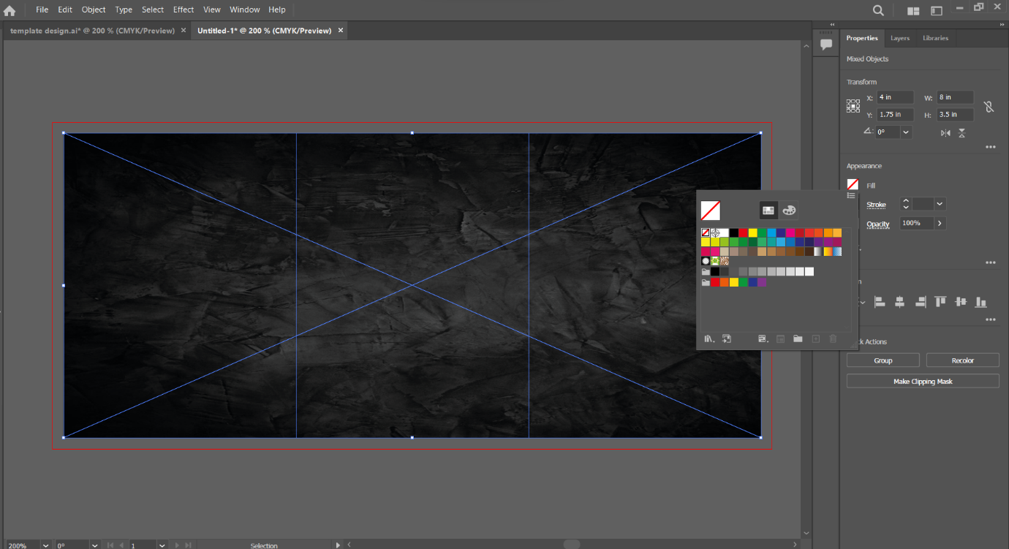
Now we can see the path line and the background picture, because I can design as easier to see the design site.

8. 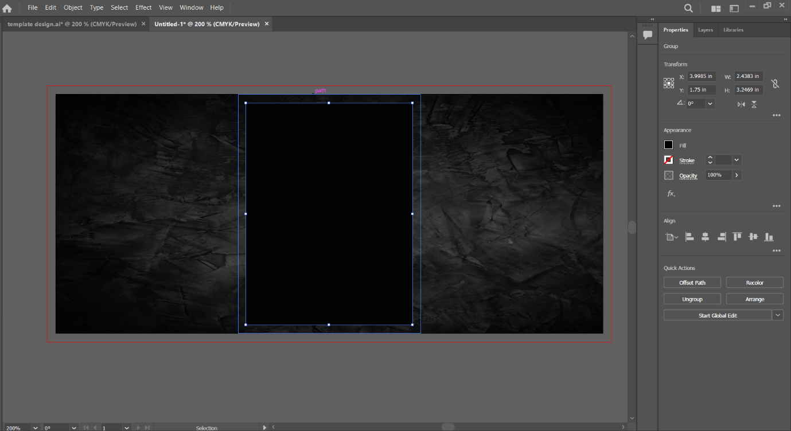
Now I started to add a new background front of the background picture.

9.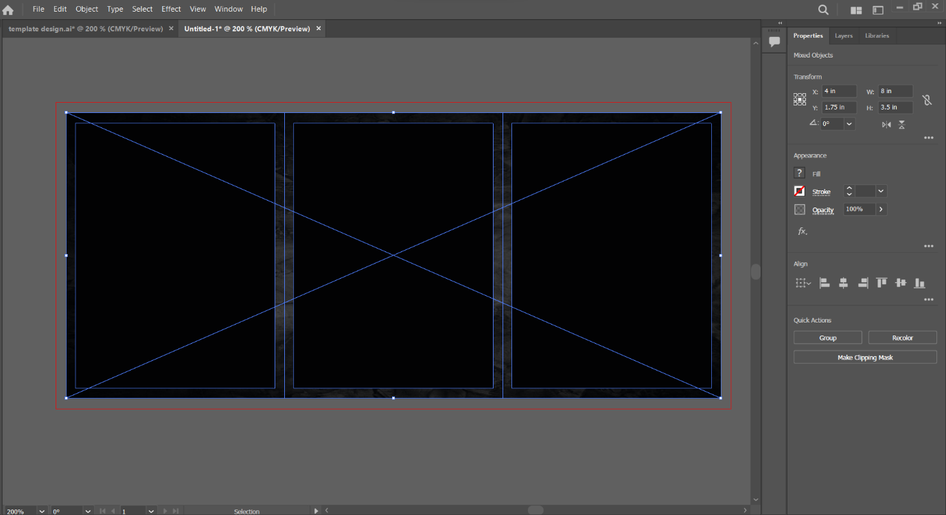

10.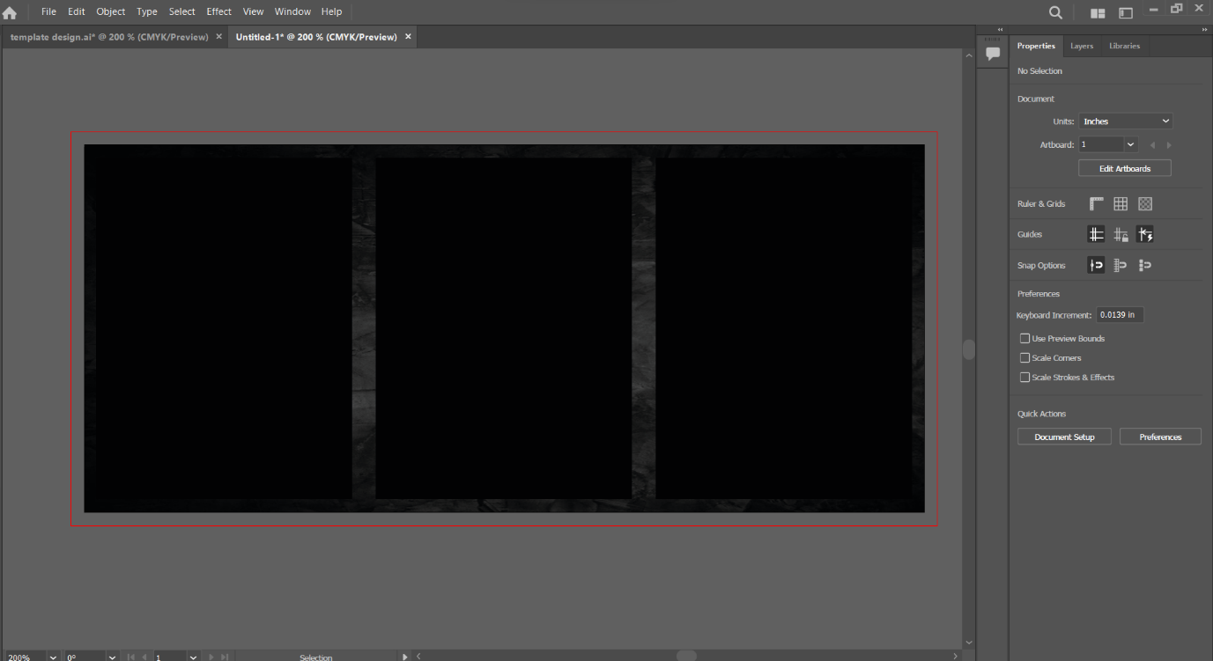

11.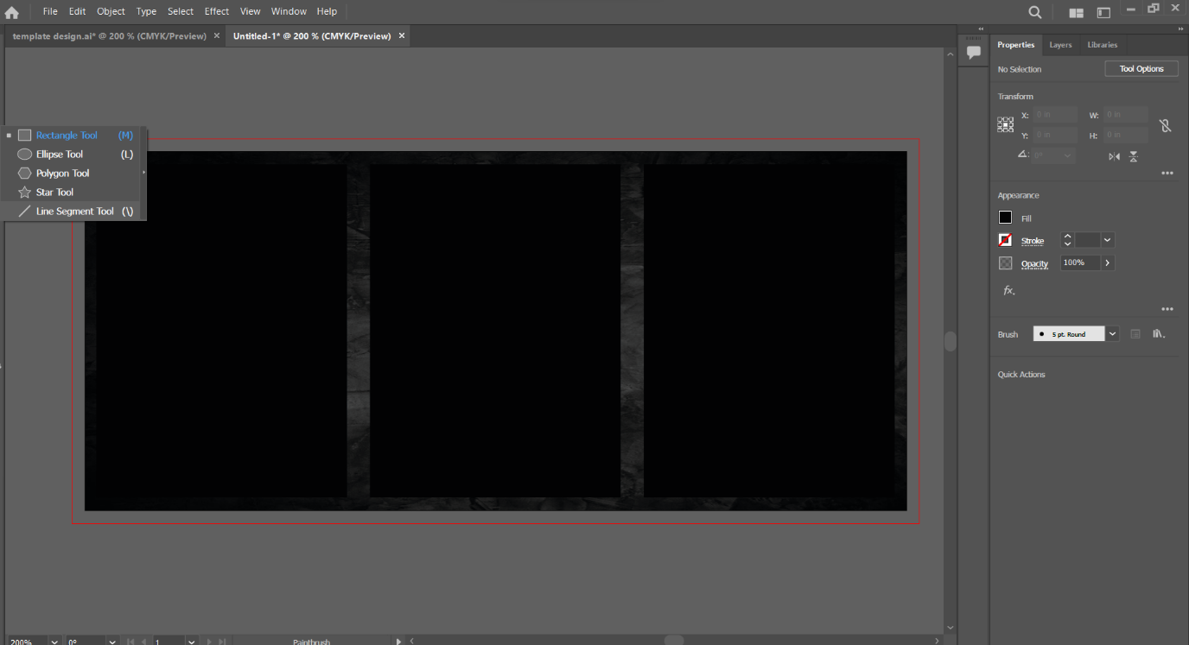
Now for the design and beautification, I use the line segment tool to draw a line at the path site.

12.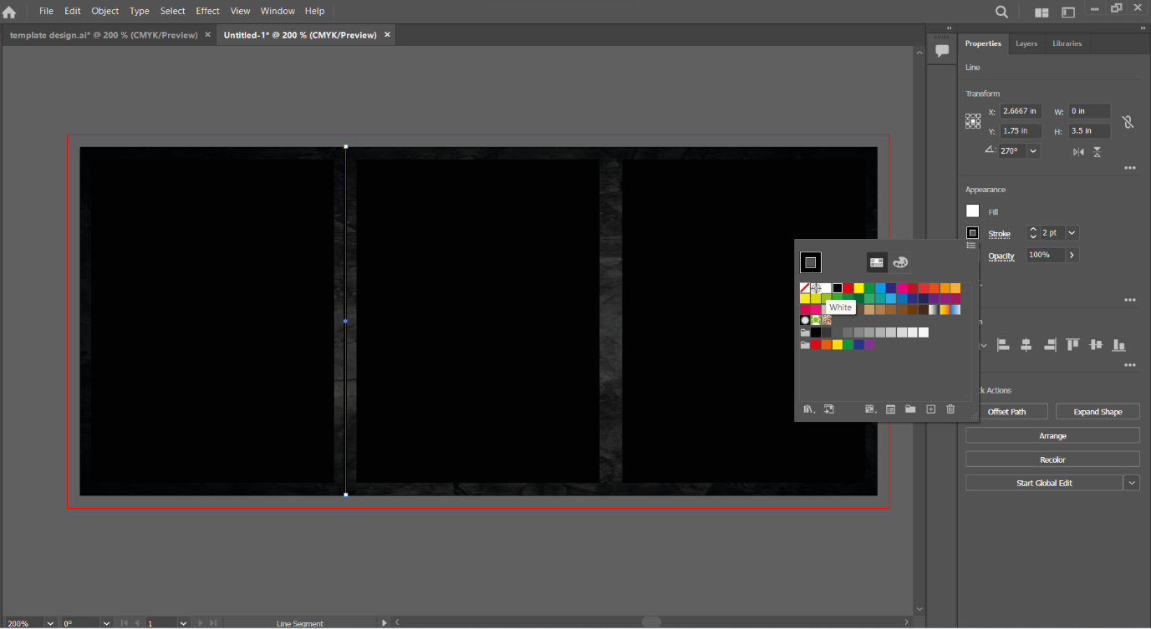

14.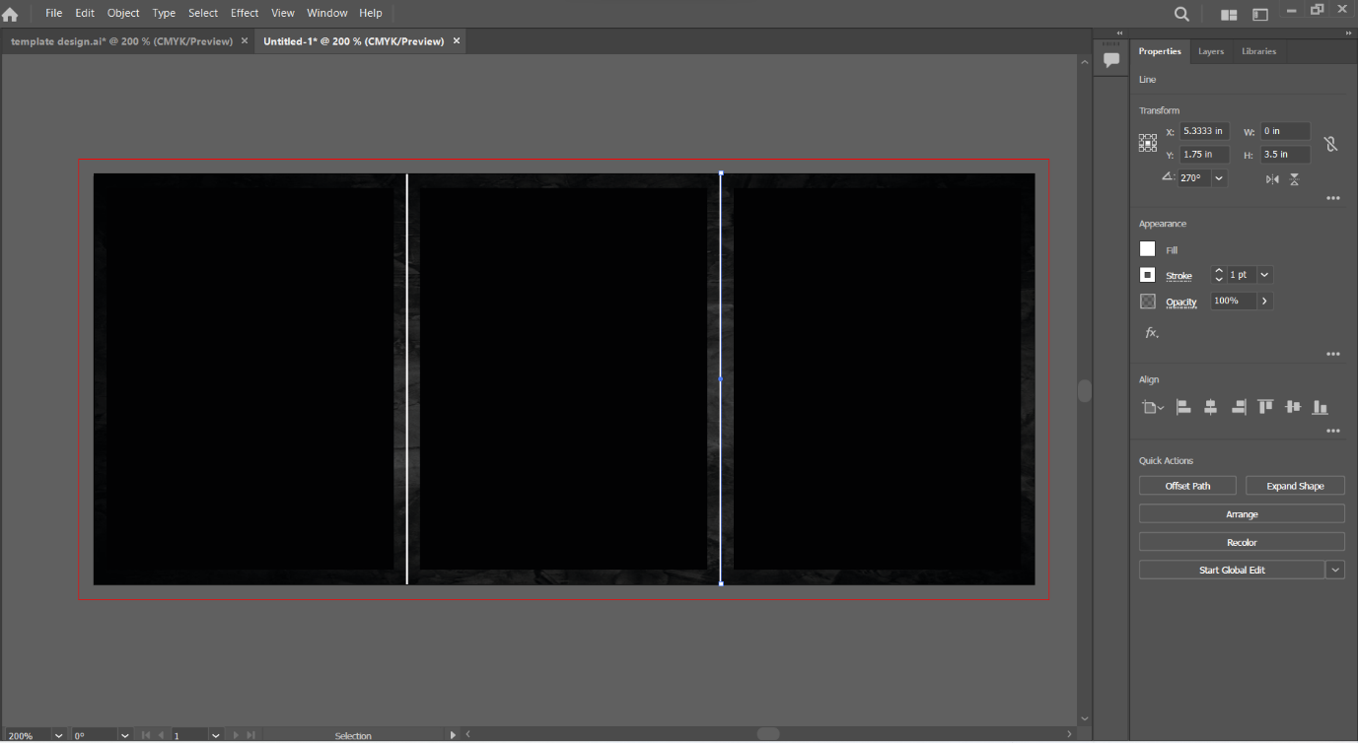
Then I had set the line stroke to 1 pt size, and use white colour.

15. 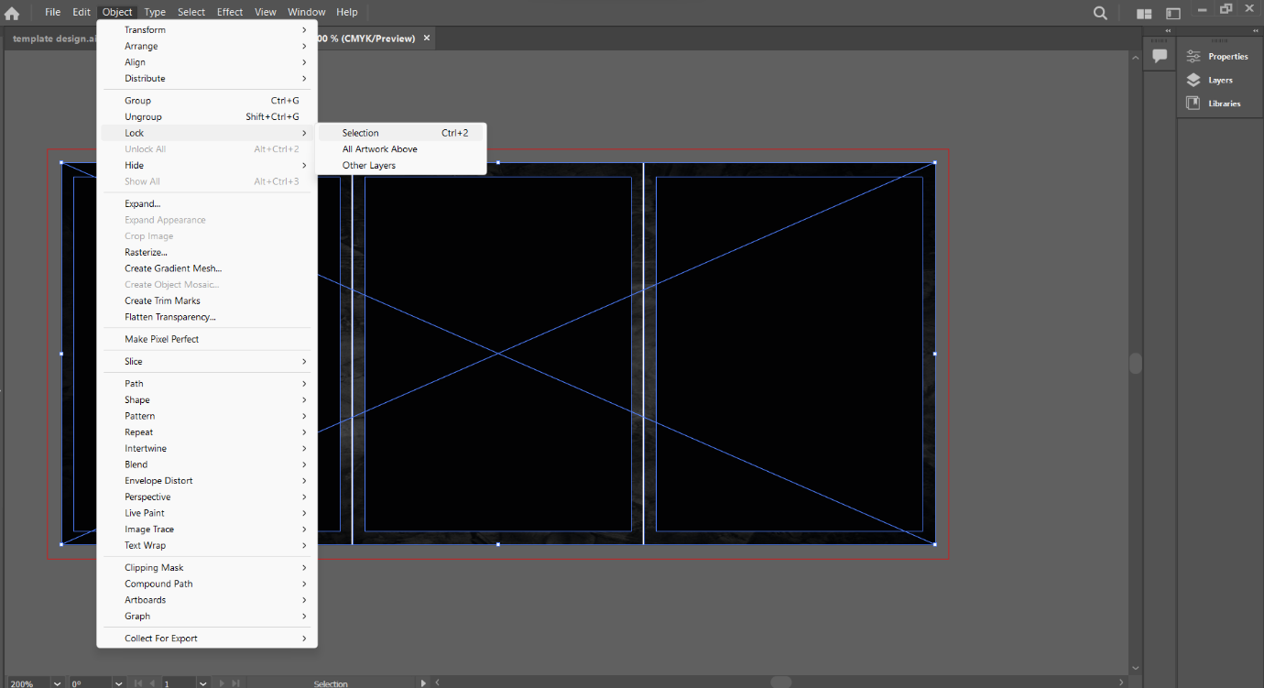
Now I select all object inside, and I lock it, because if I want to design fonts or add new patterns, it won’t affect the background position.

16.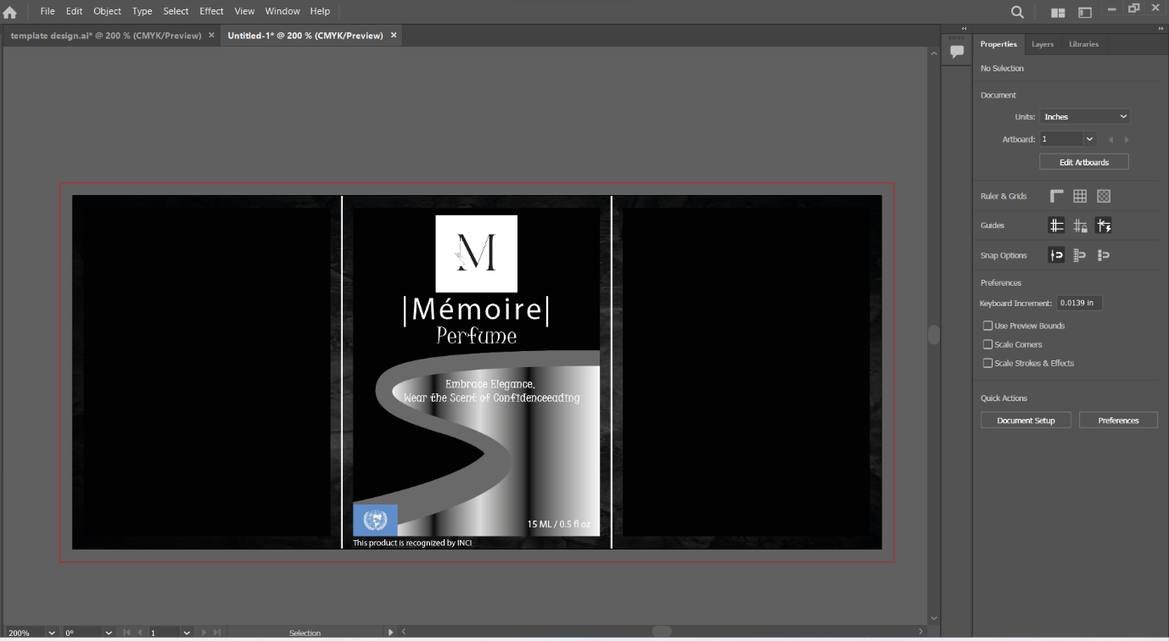
In the centre pages, the logo is a PNG file, then “memoire” is our company name, it is a memory word in French. Then I added an INCI perfume company picture below is because our perfume product has been recognized by INCI perfume company. What is INCI? INCI names (International Nomenclature Cosmetic Ingredient) are systematic names internationally recognized to identify cosmetic ingredients. Next, the “Embrace Elegance,
Wear the Scent of Confidenceeading” is our company slogan. The shape design is using curvature tool to design it.

17.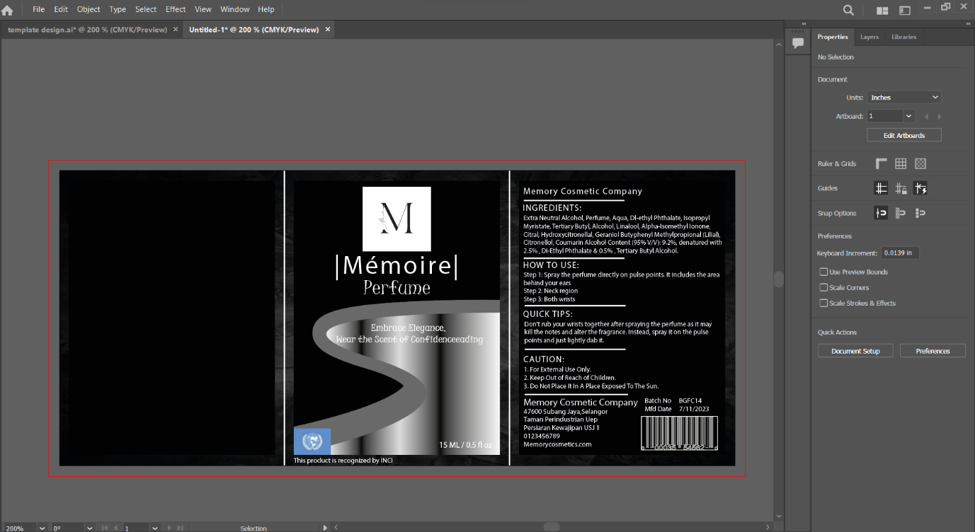
After that, I just add in our company name, ingredients, how to use, quick tips, caution, details of our company, batch number, manufactured date and the barcode of the product.

18.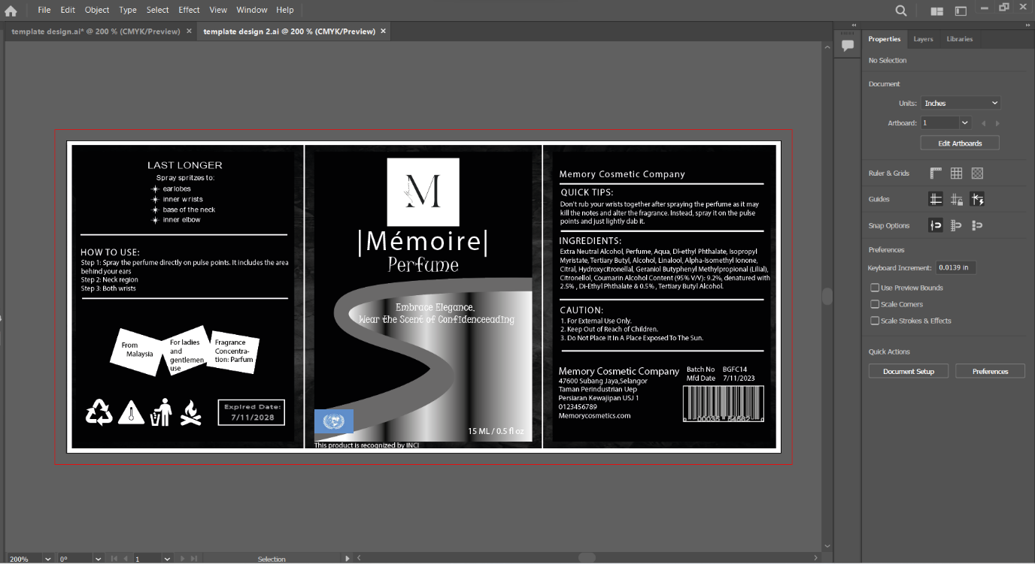
Last, I had rearrange all the word to become balance in 3 path pages, I added last longer, where our company from, this perfume is for gentlemen and ladies, fragrance concentration: parfum, expired date , and 4 of the logo. Here is all progress when I design this label template.

